ONE-DAY TOUR in DA NANG

January 12, 2026 (Mon.)
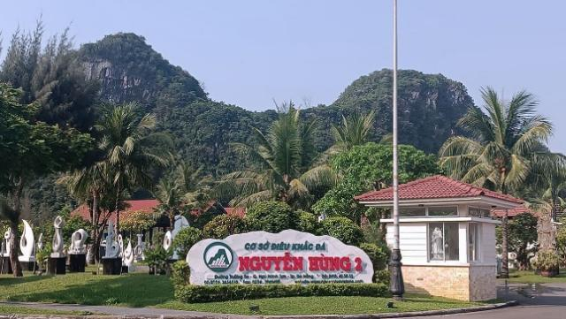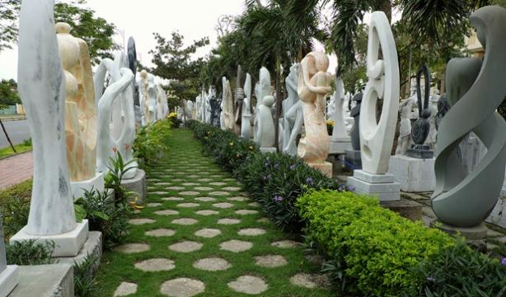
Non Nuoc Stone Carving Village
It is a historic Vietnamese village in Da Nang, famous for its traditional marble carving, located at the foot of the Marble Mountains. It is home to numerous family-run workshops where skilled artisans create a wide range of products, from small figurines to large sculptures, using marble from the nearby mountains. The village is recognized as a National Intangible Cultural Heritage and offers visitors a glimpse into the region's rich artistic and cultural legacy.


The Marble Mountains
Marble Mountains is a group of five limestone peaks situated seven kilometres from downtown Da Nang. The five karsts (called Ngu Hanh Son in Vietnamese) are named after the five elements: Kim (metal), Thuỷ (water), Mộc (wood), Hoả (fire) and Thổ (earth). Over centuries, Marble Mountains has held special significance for the people of Central Vietnam. The ancient Cham revered the karsts as a spiritual site, and Vietnamese emperors from Hue and legendary generals passing through paid visits to the peaks, adding to their store of legends.
Today Marble Mountains is home to a network of caves, tunnels, towers, and pagodas built by Mahayana Buddhists and the Nguyen Dynasty Kings. The structures and shrines blend harmoniously with nature: Vine tendrils drip from above, frangipani and poinciana trees drop their blossoms on the stone paths, and the pagodas’ ornate roofs sparkle in the tropical sun. It’s a setting that easily captures the imagination.



Hoi An Ancient Town
Hoi An is a ward of Da Nang in Central Vietnam. Hội An's Ancient Town has been registered as a UNESCO World Heritage Site since 1999 and is recognized as a well-preserved former site of a once-thriving Southeast Asian trading port dating from the 15th–19th century. Its buildings and its street plan reflect the influences, both indigenous and foreign, that have combined to produce this unique heritage site.
The town reflects a fusion of indigenous and foreign cultures (principally Chinese and Japanese with later European influences) that combined to produce this unique survival.
The town comprises a well-preserved complex of 1,107 timber frame buildings, with brick or wooden walls, which include architectural monuments, commercial and domestic vernacular structures, notably an open market and a ferry quay, and religious buildings such as pagodas and family cult houses. The houses are tiled and the wooden components are carved with traditional motifs. They are arranged side-by-side in tight, unbroken rows along narrow pedestrian streets. There is also the fine wooden Japanese bridge, with a pagoda on it, dating from the 18th century. The original street plan, which developed as the town became a port, remains. It comprises a grid of streets with one axis parallel to the river and the other axis of streets and alleys set at right angles to it. Typically, the buildings front the streets for convenient customer access while the backs of the buildings open to the river allowing easy loading and off-loading of goods from boats.

Tentative Itinerary
09:00 Depart from Duy Tân University (main gate)
09:30–10:00 (30min) Non Nuoc stone-carving village
10:00–12:00 (2h) The Marble Mountains
12:30-13:30 (1h) Lunch in Hoi An
13:30–18:00 (4h30min) Hoi An Ancient Town
18:00~19:00 Return to Da Nang (drop off at Vincom Plaza - the largest shopping mall in Da Nang)

✅ The fee includes:
Lunch; Admission tickets to all attractions

📅 Registration deadline: December 31st, 5:00 PM (UTC+7)
📩 Please send the completed form to: ipmv_conf@yeah.net

Tour Registration
One day Tour | 100 USD / Person
Online Payment Link | https://confsys.iconf.org/awxpay
E-mail: | Order Number:
Name: | Passport No.:

